Q1. MapReduce Problem Statement

All time high for all stocks -
haddop fs -put NYSE.csv cdac
hadoop jar MyJar.jar AllTimeHigh cdac/NYSE.csv exam/out1

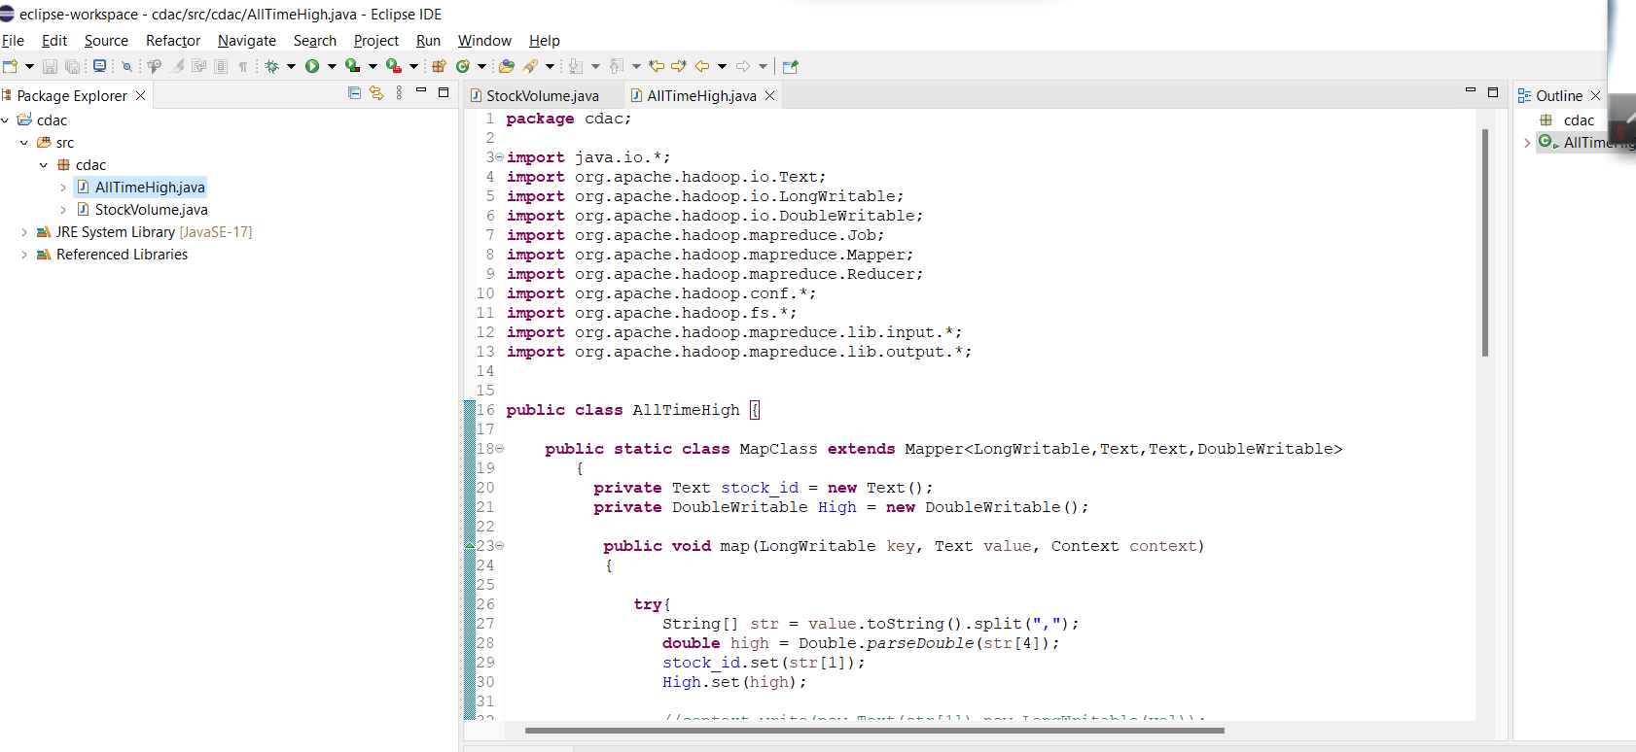

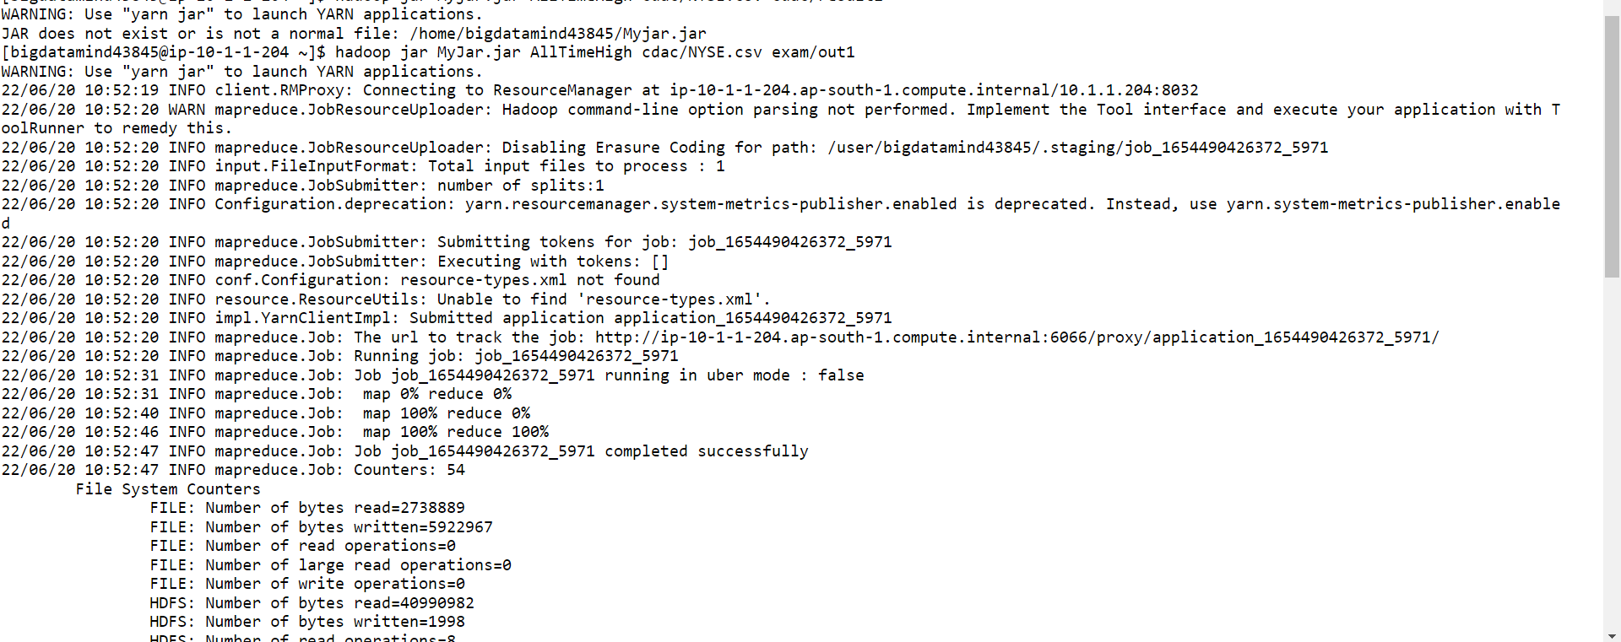

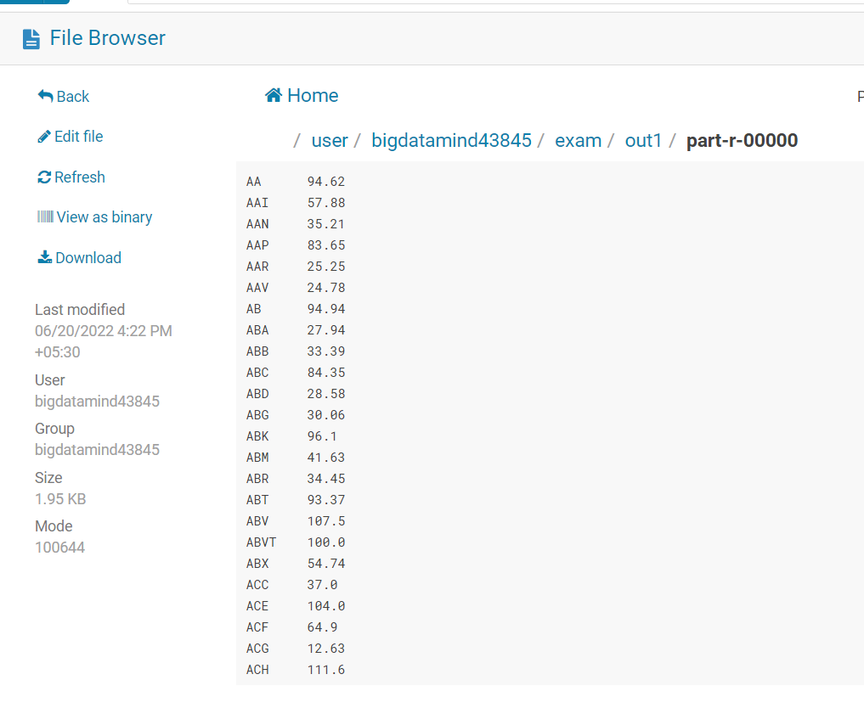

2 .Hive
1.) Write a program to find the count of customers for each profession.

hive (training_19)>hadoop fs -put custs.txt

hive (training_19)>hadoop fs -put txns1.txt

hive (training_19)>create external table customer(custno string, firstname
String, lastname string, age int,profession string)
row format delimited
fields terminated by ','
stored as textfile
location '/user/bigdatamind43845/custs.txt';
(Data is loaded while creating table)

hive (training_19)>create table txnrecords(txnno INT, txndate STRING, custno INT,
amount DOUBLE,
category STRING, product STRING, city STRING, state STRING, spendby STRING)
row format delimited
fields terminated by ','
stored as textfile
location '/user/bigdatamind43845/sales';

hive (training_19)>LOAD DATA LOCAL INPATH 'txns1.txt' OVERWRITE INTO TABLE txnrecords;

hive (training_19)> select profession, count(custno) from customer group by profession;
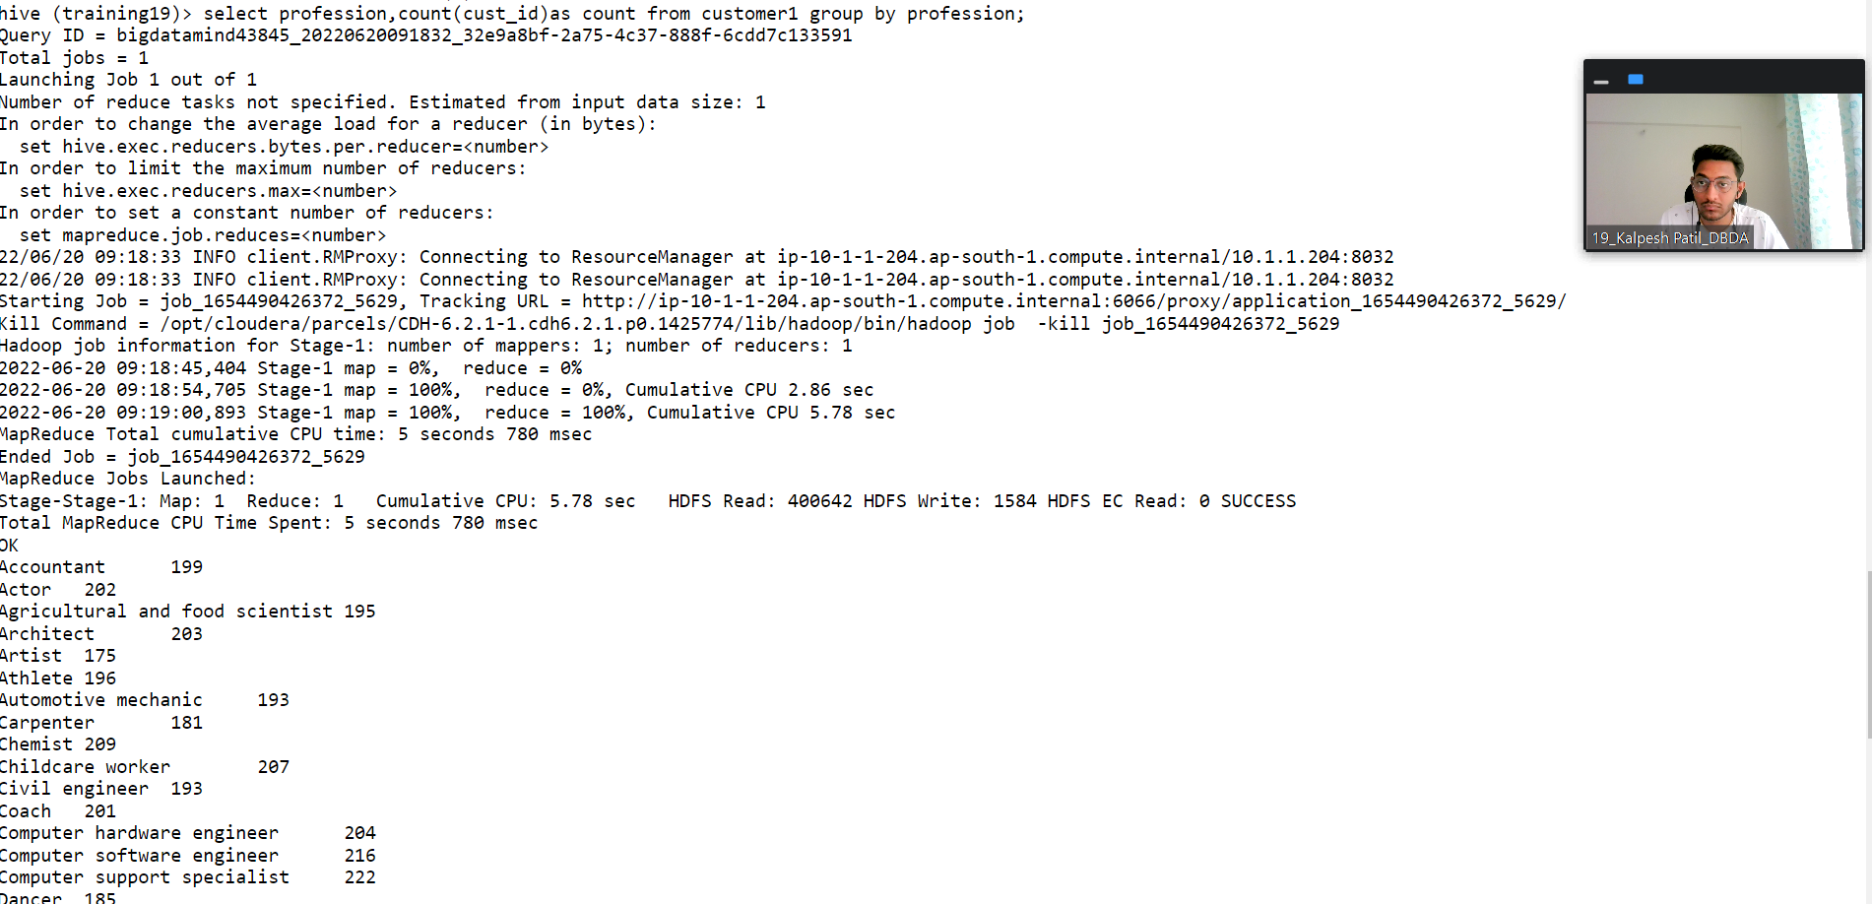
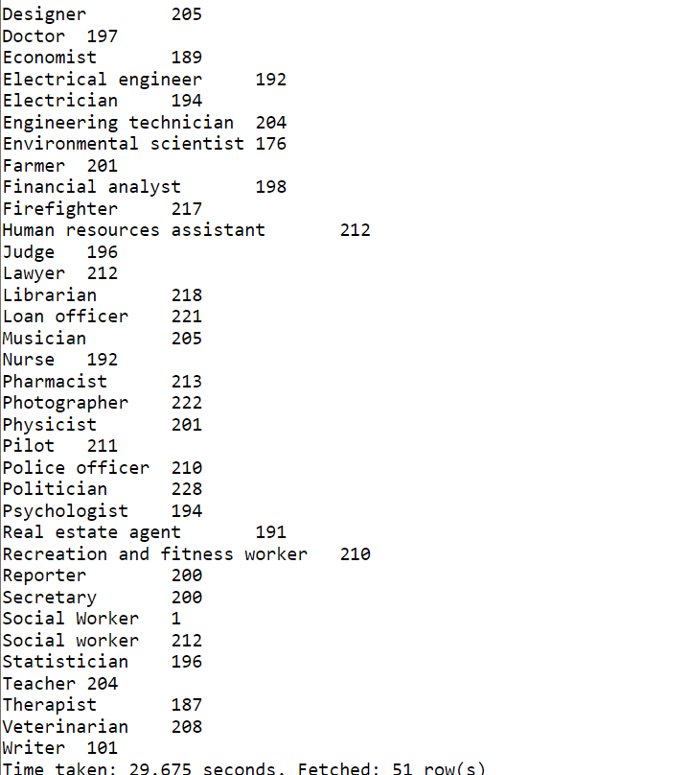

2) Write a program to find the top 10 products sales wise

hive (training_19)> select product, sum(amount) as total from
txnrecords group by product order by total desc limit 10;
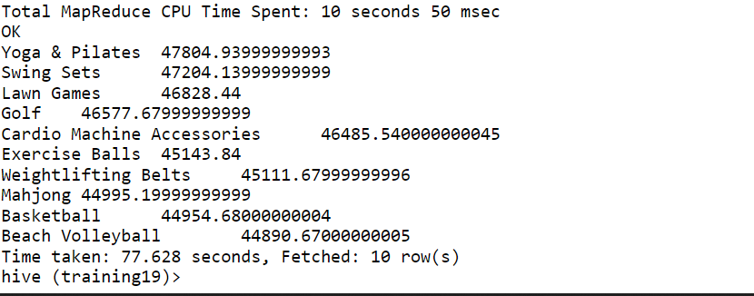

3) Write a program to create partiioned table on category
set hive.exec.dynamicpartition.mode=nonstrict;
set hive.exec.dynamicpartition=true;

create table txnrecsByCat(txnno INT, txndate STRING, custno INT, amount DOUBLE,
product STRING, city STRING, state STRING, spendby STRING)
partitioned by (category STRING)
row format delimited
fields terminated by ','
stored as textfile;

INSERT OVERWRITE TABLE txnrecsByCat PARTITION(category)
select txn.txnno, txn.txndate,txn.custno, txn.amount,txn.product,txn.city,txn.state, txn.spendby, txn.category from txnrecords txn DISTRIBUTE By category;
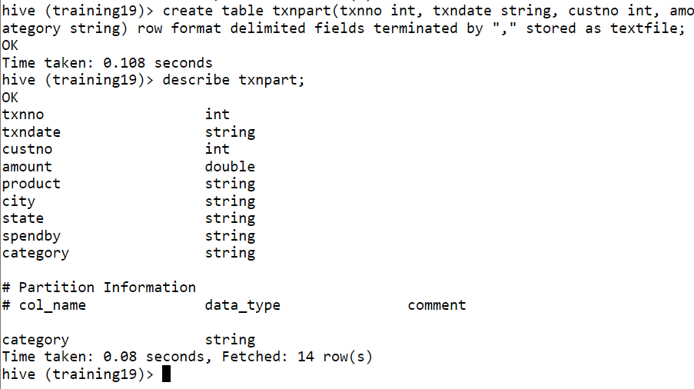

3. Pyspark

1) Write a program to find the count of customers for each profession.
airlineRDD = sc.textFile("/user/bigdatamind43846/Spark/airlines.csv")

airlineRDD1 = airlineRDD.map(lambda a : a.encode("ascii", "ignore"))

header = airlineRDD1.first()

airlineRDD2 = airlineRDD1.filter(lambda a : a != header)

arrayRDD = airlineRDD2.map(lambda a : a.split(","))

>>> key_value = arrayRDD.map(lambda a: (a[0], float(a[2])*int(a[3])))
>>> for i in key_value.collect():
... print(i)
...

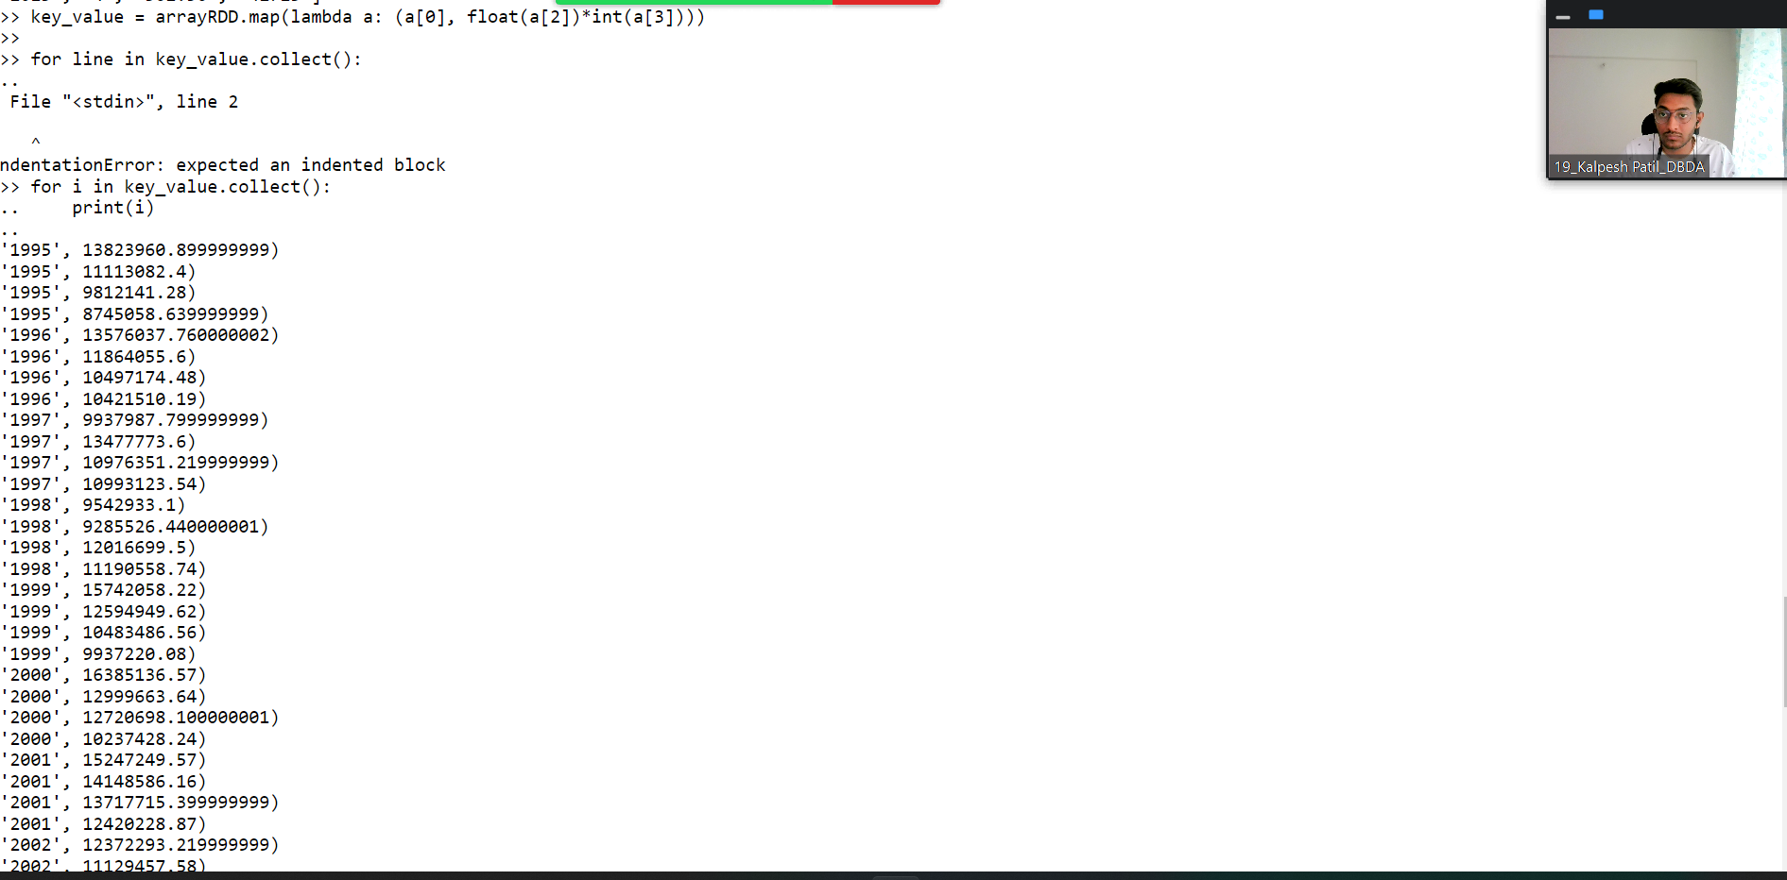

2) Identifying the highest revenue generation for which year
>>> from pyspark.sql.types import StructType, IntegerType, DoubleType, LongType, StringType
>>> schema2 = StructType().add("Year",StringType(),True).add("qtr",IntegerType(),True).add("revenue",DoubleType(),True).add("seats",LongType(),True)
>>> airlinesDF = spark.read.format("csv").option("header","true").schema(schema2).load("/user/bigdatamind43845/Spark/airlines.csv").
File "<stdin>", line 1
airlinesDF = spark.read.format("csv").option("header","true").schema(schema2).load("/user/bigdatamind43845/Spark/airlines.csv").
^
SyntaxError: invalid syntax
>>> airlinesDF = spark.read.format("csv").option("header","true").schema(schema2).load("/user/bigdatamind43845/Spark/airlines.csv")
>>> airlinesDF.registerTempTable("airlines")
>>> highest = spark.sql("select Year, sum(seats) as total from airlines group by Year order by total desc")
>>> highest.show()

3) Identifying the highest revenue generation for which year and quarter (Common group)

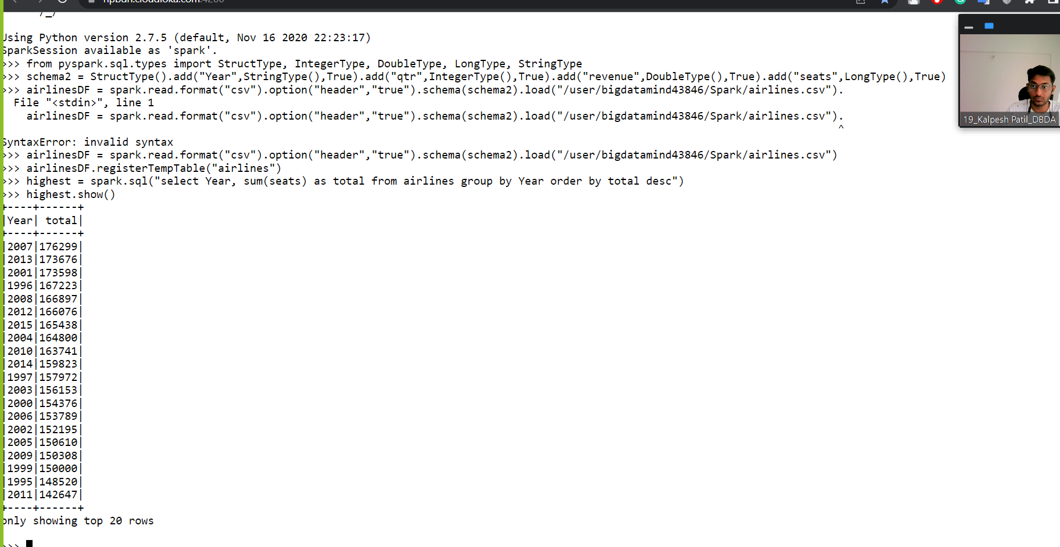

revenue = spark.sql("select Year, qtr as quarter, revenue from airlines where revenue = (select max(revenue) from airlines)")

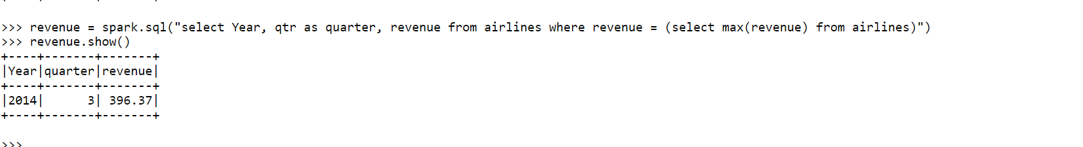
revenue.show()

